The Influence of Motivation on The Quality of Health Care Services At Hasta Husada Special Surgery Hospital: A Scoping Review

Edy Wahyudi^{1)*} Eko Ariyanto¹⁾ Andy E Krisna¹⁾
Wisnuwardhana University
fulloboo@gmail.com

ABSTRACT
The impact of motivation on the caliber of health worker services at Hasta Husada Special Surgery Hospital has been examined in earlier literature studies. This scoping review's goal is to map out previous research that evaluates how work motivation affects the caliber of services provided by health workers. Finding research questions, finding pertinent studies, choosing studies, mapping data, and gathering, summarizing, and reporting findings are the five primary steps of a scoping review. According to the scoping review's findings, the majority of studies conducted over a ten-year period (2013–2023) recognized that job motivation affected the caliber of hospital services. However, according to Cicilia Lihawa et al. (2016), Titi Nur Wahidah (2017), and Andreano C. Porotu'o et al. (2014), work motivation had no bearing on the quality of services.
Keywords: Motivation, Service Quality, Review Scoping

INTRODUCTION
According to PMK NO. 3 of 2020 concerning Hospital Classification and Licensing, 2020, a hospital is a health service organization that offers comprehensive individual health services, including preventive, curative, rehabilitative, and promotional services through inpatient, outpatient, and emergency services. When a hospital provides high-quality services, it is considered to be effective in fulfilling its duties.
Health professionals are one of the factors that must be reached in order to raise the caliber of hospital services (Hidayat, 2017). Therefore, in order to have professionals who are experts in their disciplines, a hospital must train its staff. Health professionals with skills and knowledge will perform well and be driven to complete all of their tasks (Nursalam, 2014). Motivation is essential because motivated personnel will work more assiduously and enthusiastically, which will improve performance.
According to Nursalam (2014), motivation is an emotion or idea that propels someone to work hard or use their power, particularly in conduct. According to Christine Effendy (2009), in addition to the individual's awareness, other people must also be able to inspire a health professional because their presence will stimulate their motivation. This implies that in order to raise the standard of care, a hospital needs to employ medical professionals who are knowledgeable in their specialties.
The foundation of a hospital's survival is its quality. Hospitals must adhere to professional and medical norms of ethics while providing high-quality treatments under this paradigm. Hospital managers find it challenging to provide the highest quality of care because the services they provide affect the patients' quality of life, and any medical error could have a negative effect on the patient from worsening their illness or disability to death (Jacobalis, 2000). Hospitals must thus constantly enhance their medical services in light of the health sector's rapid technological advancements and fierce competition (Supriyanto S & Djohan AJ, 2002). In order to satisfy patients, health services must improve the quality of their offerings. It is impossible to separate a patient's satisfaction with the quality of health care from the quality of the services they receive; high quality is linked to recovery from illness, improved health, speed of service, a pleasant care environment, friendly staff, ease of procedure, completeness of equipment, medications, and reasonable costs (Pohan, 2003).
Hasta Husada Special Surgery Hospital is a medical facility or organization that offers exceptional surgical services under its umbrella. Naturally, as a business in the service industry, quality or quality of service serves as a standard for publishing and maintaining high-quality health products, ensuring that patients or clients will stick with the hospital and become devoted to it when they require medical care. The following table shows patient complaints about hospital services for the first three months of 2023, based on information gathered by Hasta Husada Special Surgery Hospital's Public Relations Sub-Division:
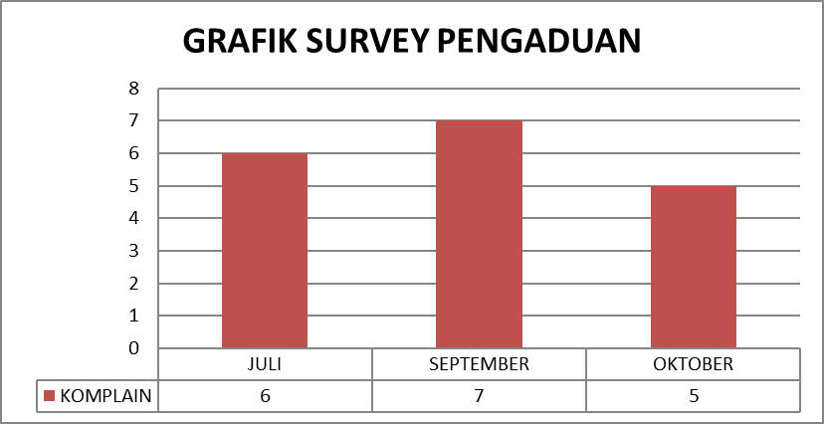
Source: Monthly Report of Public Relations Sub-Section.
Figure 1: Sampling graph of patient complaint survey for each unit/installation for 3 months in 2023.
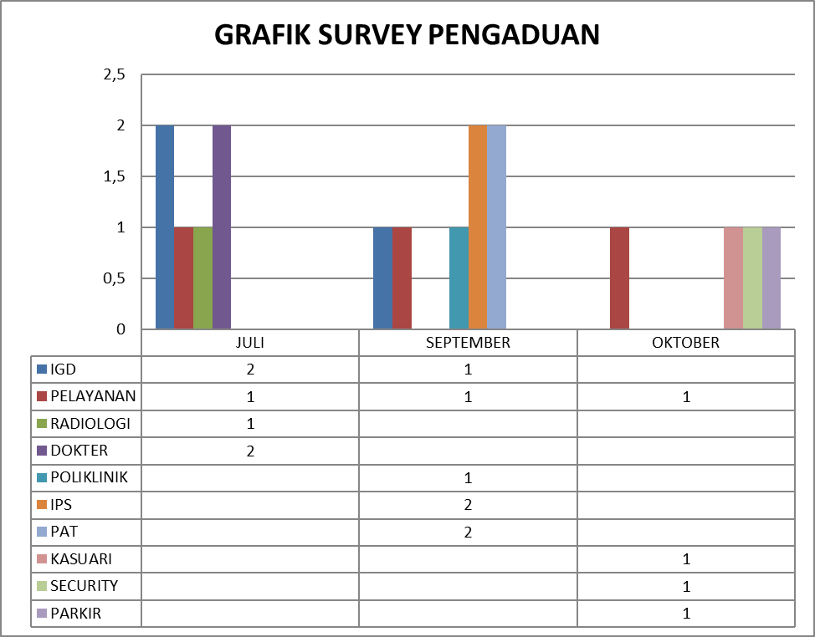
Source: Monthly Report of Public Relations Sub-Section.
Figure 2: Sampling graph of patient complaint surveys for each unit/installation for 3 months in 2023 that appear on Google Review.
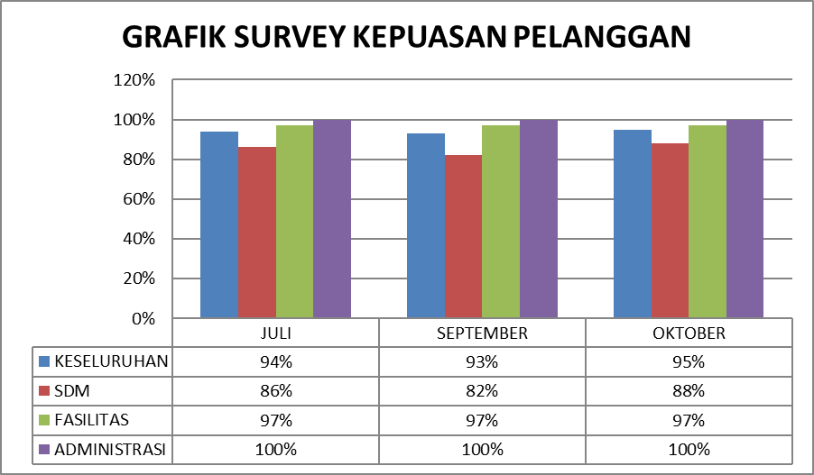
Source: Monthly Report of Public Relations Sub-Section.
Figure 3: Sampling graph of the recapitulation of satisfaction surveys for each unit/installation for 3 months in 2023
The data from the above-mentioned data attachment reveals a phenomenon: a gap or incident pertaining to customer satisfaction and complaints that prevents the quality of hospital services from being met by each of its indicators. This is demonstrated by the procurement of HR-related complaint data, which had an average success rate of 85.3%, 97% from the Facilities side, and 100% from the Administration side. In this case, the results obtained are less than 100%, indicating that there is still a lack of public or customer trust in the quality of service at the hospital. The average complaint or complaint for three (three) months was 94%, whereas the complaint indicator should have been 100%, indicating that patient satisfaction is well maintained.
According to the data derived from the above graphic presentation, human resources—in this example, healthcare workers—are the primary cause of the drop in service quality. Health personnel continue to have numerous job motivations and attitudes when serving patients that are not optimal and good, which prevents service quality from being accomplished, according to data presented by the Head of the Public Relations and HR Sub-Division and the results of field interviews. An internal component that guides and propels an individual's behavior toward achieving specific objectives is known as work motivation.
The ideas of wants, urges, goals, and rewards are all combined to create an individual's work motivation (Tewal et al., 2017). Health professionals' drive or desire to perform their responsibilities and obligations as professional health workers in an objective manner is known as their job motivation. Although a health worker's attitude affects motivation, attitude is a psychological state and feeling, whether positive or negative, that is frequently prepared, learned, and controlled through experience. It has a particular impact on how a person reacts to other people, situations, and objects (Tewal et al., 2017). A professional attitude is a person's or individual's attitude toward the advantages of tasks, completing tasks, enjoying work, being satisfied with work, working hard, and wanting to succeed in a career (Muljono, 2008).
A number of earlier studies (Nivalinda et al., 2013; Porotu'o et al., 2014; Maryani Lydia, 2015; Okello & Gilson, 2015; Zainaro et al., (2017); Astuti et al., 2018; Baljoon et al., 2018; Sayekti et al., 2022; Mahmud et al., 2023; AndAnum Farida & Chaerudin, 2023) looked at the relationship between work motivation and the quality of health worker services. This finding, however, differs from that of studies by Amin & Nasharuddin (2013), Mosadeghrad (2014), Lihawa Cicilia et al. (2016), Weldegebriel et al. (2016), and Nurwahidah Tity (2017), which found no correlation between hospital health workers' motivation and the quality of their services. There is a research gap that necessitates more investigation on hospital health service quality and motivation.
It is anticipated that this study will help researchers manage the quality of hospital services, specifically in relation to motivation and the quality of health worker performance services, at Hasta Husada Special Surgery Hospital. The findings of this study are anticipated to serve as a reference and advance knowledge of hospital quality theory, particularly with regard to the connection between job motivation and the caliber of healthcare worker services provided in hospitals, in addition to academic purposes.
METHOD
This study is a review of the literature, which aims to find, assess, and interpret research findings on certain subjects or phenomena that researchers are interested in (Kitchenham et al., 2007). In order to provide readers with a synopsis of ideas and empirical findings pertaining to the subject under investigation, researchers in literature reviews do a theme synthesis compiled from the findings of prior study (Cisco, 2014). According to Daudt et al. (2013), a scoping review is a review of the literature used to summarize study findings. With the steps of gathering, analyzing, and reporting the results—which include descriptive and numerical summaries of the data and thematic analyses of chosen journals—a scoping review aims to map the body of existing literature in the field of interest in terms of the quantity, type, and features of the primary research examined (Pham et al., 2014).
Identifying Research Questions
Identifying research questions at the initial stage of the research review, because by determining research questions, researchers can design a strategy to conduct a literature search by ensuring substantive areas with research topics. The research question is How is the existing literature on the relevance of motivation and quality of health worker services in hospitals.
Identifying Relevant Studies
The study's secondary data comes from prior studies on the quality and motivation of health worker services that were found online through searches of national and international scientific journals. Research journal papers about hospitals that look at the quality and motivation of health worker services in different nations meet the requirements for journals to be evaluated.
Table 1 shows the criteria utilized in the literature search procedure. The time span used is ten years, from 2013 to 2023. Ten years is thought to be enough time to track the applicability of studies on hospital health service staff quality. The publications that were chosen are empirical works published in both Indonesian and English. The geographic region is not restricted to any particular nation. As long as they satisfy the other previously stated requirements, all empirical studies from other nations are included in the criteria.
Table 1. Inclusion criteria
Criteria | Inclusion
Period | 2013-2023 | 10 years of observation
Language Types | English  Indonesian | Articles are published using English and Indonesian.
Publication Type | Journal article | Empirical articles
Geographical Area | All | Findings from all Countries
Study Selection
The results of three electronic database searches using Scopus, Crossref, and Google Scholar. These publications were then scrutinized to ensure that they addressed the subject of the study. Papers were also checked for possible duplication in other databases. The majority of the studies did not address the research question since they did not discuss the relationship between motivation and the quality of health professional services.
Mapping Data
Selected articles are extracted to provide a summary of the most significant data during the data charting stage. The author, title, research year, research site, design or methodology, and findings are among the information that was documented. The following is a map of the research data that is included:
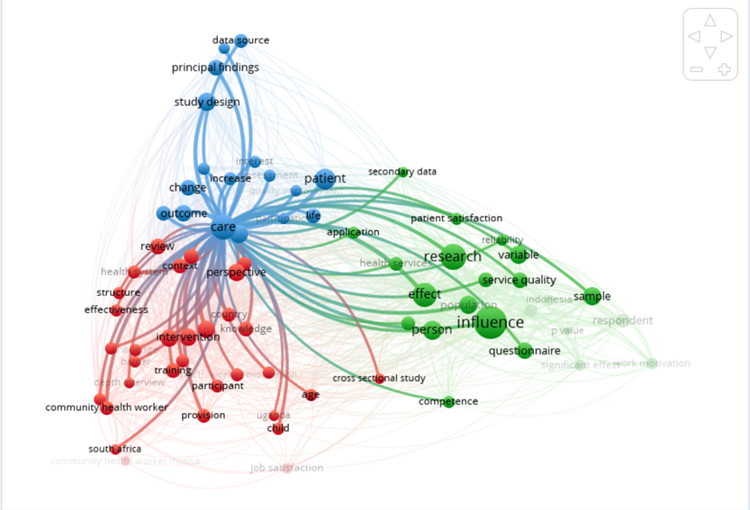
Figure 4: Data map (Vos Viewer) with crossref method between motivation and service quality
Compiling, Summarizing and Reporting Results
The final stage of the scoping review is compiling, summarizing, and reporting the research results. Compiling produces a table containing the article extractions carried out at the data mapping stage. Summarizing produces the main themes or patterns of the main findings, and reporting produces the report format, which in this case is for publication purposes.
Table 2. Results of data collection
No | Author | Title | Year | Location | Design/Method | Results Study
1 | Nivalinda D et al. | The Influence of Motivation and Leadership Style of the Head of the Room on the Implementation of Patient Safety Culture by Nurses at Government Hospitals in Semarang | 2013 | Semarang | 105 respondents used the questionnaire.  Type of non-experimental quantitative research with a cross-sectional approach. Data analysis with product moment, simple regression, multiple linear regression. | The study's findings demonstrated that the adoption of a patient safety culture was impacted by nurse motivation.
2 | Muslim Amin et.al. | Hospital service quality and its effects on patient satisfaction and behavioral intention | 2013 | Kuala Lumpur, Malaysia | 350 questionnaires (response rate 61.7%). Convenience sampling technique. | The five dimensions of hospital service quality—patient admission, medical services, overall hospital services, patient discharge, and social responsibility—were validated by the study.
3 | Ali Mohammad Mosadeghrad | Factors Affecting Medical Service Quality | 2014 | Tehran, Iran | In-depth exploratory individual interviews were conducted with sixty-four (64) physicians working in various medical institutions in Iran.  The research is descriptive qualitative. | The study's findings show that both internal and external factors—specifically, organizational, environmental, and individual factors—can help or hurt the quality of medical services. The standard of healthcare is determined by on the individual characteristics of physicians and patients, as well as elements pertaining to the healthcare setting and the broader environment.
4 | Andreano C. Porotu'o et al. | The Influence of Work Motivation and Professional Attitude on Nurses' Performance in Inpatient Services at GMIM Pancaran Kasih Manado General Hospital Through Job Satisfaction as a VariableIntervening | 2014 | Manado | Eighty nurses. cross-sectional study using a quantitative research design and analytical survey (positive sampling). IBM SPSS Statistics 22 is used for univariate data analysis, and Smart PLS 3.0 is used for multivariate data analysis utilizing Structural Equation Modeling (SEM). | The study's findings show that nurse performance in inpatient services at GMIM Pancaran Kasih Manado General Hospital is directly impacted by job satisfaction, and that nurse performance is indirectly impacted by professional attitude.
5 | Lydia Maryani | The Influence of Motivation and Quality of Nursing Services on Inpatient Patient Satisfaction in Hospitals | 2015 | Bandung | 806 patients met the requirements for inclusion. Tests of questionnaire validity and reliability, normalcy, linearity, multicollinearity, autocorrelation, multiple correlation, and multiple linear regression were among the data analytic techniques employed. | The study's findings indicated that inpatient satisfaction at the hospital is positively impacted, partially and simultaneously, by nursing service quality and motivation.
6 | Dickson RO Okello and Lucy Gilson | Exploring the influence of trust relationships on  motivation in the health sector: a systematic  review | 2015 | South Africa | By offering five (five) electronic databases for searching publications with study findings on health worker motivation from all website lines published within a ten-year period (2003 to 2013), a systematic review approach was used. By locating direct and indirect research and talking about pertinent aspects, data extraction takes into account the connection between motivation and trust. | The findings of this study show that employee motivation (health professionals) is influenced both directly and indirectly by the relationship of trust in the workplace with coworkers, managers and supervisors, workplace organizations, and patients. backed by 23 papers that satisfy the quality and inclusion requirements (thematic synthesis) and come from low- to high-income nations.
7 | Cicilia Lihawa et al. | The Influence of Work Motivation on Doctors' Performance in  Completeness of Medical Record Filling with Moderation  Individual Characteristics  (Study at Unisma Islamic Hospital Malang) | 2016 | Poor | 45 physicians used the linear regression test as the data analysis approach.  This study employs a cross-sectional methodology and is observational. | According to the study's findings, management does not have to consider individual traits in attempts to boost physicians' motivation in order to enhance their performance when filling out medical records. However, it was discovered that the impact of work motivation on doctors' performance in finishing RM was not moderated by gender, age, or duration of service.
8 | Zemichael Weldegebriel, et.al. | Motivation of health workers and associated  factors in public hospitals of West Amhara,  north ethiopia | 2016 | Western Ethiopia | 304 medical specialists. Eight general hospitals participated in a cross-sectional study that was facility-based.  West Amhara.  SPSS Software Version 2.0 was used to examine the data that was gathered.  Reliability is evaluated  Cronbach's alpha. | The study's findings demonstrated that there was no discernible difference between health workers' overall motivation level and their absolute compensation level.  Strongly correlated with health personnel' general motivation level.
9 | M. Arifki Zainaro et al. | The Influence of Work Motivation on the Performance of Nurses in the Inpatient Ward of Alimuddin Umar Regional General Hospital, West Lampung Regency in 2017 | 2017 | West Lampung | 60 people responded. The research is cross-sectional and quantitative in nature.  The entire population is sampled using this method. Chi Square bivariate analysis. | The performance of the nurses in the inpatient ward of Alimuddin Umar Regional Hospital, West Lampung Regency, is correlated with their motivation for their jobs.  According to this study, 32 (53.3%) of the implementing nurses at the inpatient ward of Alimuddin Umar Regional Hospital in West Lampung Regency had low levels of job motivation.
10 | Tity Nurwahidah | The Influence of Work Motivation and Employee Discipline  On Service Quality At PT. Hero  Supermarket Tbk In Makassar. | 2017 | Macassar | Multiple linear regression analysis is the method employed.  Two independent variables are used in this influence measurement (motivation X1 and  discipline X2) and service Y, the dependent variable. | The study's findings demonstrate that service quality is unaffected by staff motivation.
11 | Rini Astuti et al. | The Influence of Motivation and Workload on Nurse Performance  at Mitra Medika General Hospital Medan | 2018 | North Sumatra | For the data population, there were 32 nurses.  The method used to gather data for this study is  questionnaires, documentation studies, and interviews, but the methods  The traditional assumption test, multiple regression, T test, F test, and other data analysis techniques are employed as well as the coefficient of determination. | Workload and motivation have an impact on performance.  The R-count for nurses at Mitra Medika General Hospital in Medan was 0.349.
12 | Reem A Baljoon, et.al | Nurses' Work Motivation and the Factors Affecting It: A Scoping Review | 2018 | Saudi Arabia | MEDLINE, PubMed, Science Direct, the Cochrane Library, and the Cumulative Index to Nursing and Health Literature  Pro Quest, Ovid, and Allied (CINAHL) databases, 2011–2017 (Scooping Review). keywords pertaining to nurse performance and motivation. | According to the research, a number of organizational and personal factors affect nurses' motivation at work.
13 | English: Sri Sayekti Heni Sunaryanti, et.al. | Meta Analysis: The Relationship between Hospitals  Management on Work Motivation among Nurses | 2022 | Surakarta | Eight cross-sectional research publications from Europe (Switzerland), Africa, and Asia (Indonesia, Malaysia, and Japan)  A meta-analysis of North America (United States) and Ghana was conducted.  The selection of articles is done using  PRISMA flow chart. The Review Manager 5.3 program was used to assess the articles. | The analysis's findings indicated that the hospital was managed well can boost nurses' passion for their jobs 1.91 times more than inadequate hospital administration (p = 0.01) and the findings were statistically significant (1.91; 95% CI = 1.16 to 3.15).
14 | Ilias Mahmud, et.al. | Factors influencing motivation of close-to-community sexual and reproductive health workers in low-income urban settlements in Bangladesh: A qualitative study | 2023 | Bangladesh | Qualitative research.  22 medical professionals responded.  Employing framework approaches for data analysis that include matching, abstraction, graphing, and identification  The interview approach and theme are based on Herzberg and colleagues' two-factor theory of job motivation. | The study's findings indicate that the elements influencing health workers' motivation at work.  Both intrinsic and extrinsic factors are involved in sexual and reproductive CTC.
15 | Farida Anum and Chaerudin | The Influence of Work Motivation on Employee Performance at Hermina Karawang Hospital. | 2023 | Karawang | Descriptive and causal quantitative methodologies are used in this investigation. 187 workers participated in the survey.  Probability sampling using the basic random sample method (Slovin calculation method) was the sampling strategy used in this investigation. | The study's findings suggest that staff performance at Hermina Karawang Hospital is significantly impacted by job motivation.

RESULT
The research was carried out using 15 empirical studies that are relevant to the research objectives and a 10-year time span, with 60% of the studies coming from Indonesia and 40% from outside of it. This study looks at the relationship between motivation and the quality of services provided by health workers (Nivalinda et al., 2013; Amin & Nasharuddin, 2013; Porotu'o et al., 2014; Mosadeghrad, 2014; Maryani Lydia, 2015; Okello & Gilson, 2015; Lihawa Cicilia et al., 2016; Weldegebriel et al., 2016; Zainaro et al., (2017); Astuti et al., 2018; Baljoon et al., 2018; Sayekti et al., 2022; Mahmud et al., 2023; AndAnum Farida & Chaerudin, 2023).
A study by Nivalinda et al. (2013) involved 105 participants at the Semarang Government Hospital. By using nurses at the Semarang Government Hospital, the study sought to ascertain how nurse motivation and the head of the room's leadership style affected the adoption of a patient safety culture. The results of the study indicated that the head of the room's leadership style had a 36.8% impact on the implementation of patient safety culture, while nurse motivation had a 10.3% impact. The head of the room's leadership style and nurse motivation had a combined 39.2% impact on the adoption of a patient safety culture. Nurse motivation and the leadership style of the head of the room had an impact on the Semarang Government Hospital's establishment of a patient safety culture. Suggestions: It is intended that government and commercial organizations will investigate more thoroughly connected to other elements and causes that affect service quality simultaneously through regulations if organizations wish to create a patient safety culture in multiple hospitals.
Amin and Nasharuddin (2013) carried out a study on how patient satisfaction affects service quality in Malaysian hospitals. A total of 350 questionnaires were sent out, and 216 of them were returned (response rate: 61.7 percent). This study sought to ascertain hospital service quality and its impact on patient satisfaction and health service users' behavioral patterns. The study's findings demonstrate that there are five aspects of hospital service quality: medical services, discharge, overall services, social responsibility, and patient admission. These are distinct constructs for hospital service quality. The quality of hospital services is significantly correlated with each dimension. According to the study's findings, raising the bar for hospital service quality will result in happier patients and more positive behavioral intentions. Recommendation This study looks at patient happiness, behavioral intentions, and hospital service quality from the viewpoint of the patient. However, it should be noted that the viewpoint of the service provider is not examined in this study. This is a drawback since it solely takes the patient's perspective into account, which may not align with the service provider's perspective.
In order to determine the factors that affect the quality of healthcare services offered in Iranian healthcare organizations, Mosadeghrad (2014) conducted extensive exploratory individual and focus group interviews with 222 healthcare stakeholders, including payers, managers, policy makers, and healthcare providers. Finding the variables that affect healthcare service quality in the Iranian environment was the primary goal of this study. The findings demonstrated that both internal and external factors—specifically, organizational, environmental, and individual factors—can either improve or degrade the quality of medical care. The personal characteristics of physicians and patients, as well as elements pertaining to the healthcare setting and the broader environment, all influence the quality of medical services. This article concludes that by creating a conceptual framework that gives managers and policymakers a useful understanding of the elements influencing healthcare service quality, it can advance the theory and practice of healthcare services.
Using a purposive sample approach, Porotu'o et al. (2014) studied 80 nurses working in the inpatient department of GMIM Pancaran Kasih General Hospital in Manado. The data analysis process included both univariate analysis with IBM SPSS Statistics 22 and multivariate analysis with Smart PLS 3.0's Structural Equation Modeling (SEM) tool. This study used job satisfaction as an intervening variable to examine professional attitudes and work motivation regarding nurse performance in the inpatient service of GMIM Pancaran Kasih General Hospital Manado. The findings demonstrated that in the inpatient service of GMIM Pancaran Kasih General Hospital Manado, job satisfaction had a direct impact on nurse performance, while professional attitude had an indirect impact on nurse performance through job satisfaction.
Using an average sample size of 806 patients every month, Maryani Lydia (2015) studied all inpatients at Bandung Hospital. Patients who met the following inclusion criteria were utilized as samples: they had to be inpatients receiving treatment for at least two days, have mild to moderate diagnoses, and be cognizant and able to talk. The results of the study indicate that inpatient satisfaction at the hospital is positively impacted, partially and simultaneously, by nurse service quality and motivation (p <0.05). There is a strong association between the patient satisfaction variable (Y) and the motivation variable (X1), according to the findings of the study on the impact of motivation on service quality. This implies that the more motivated healthcare professionals are to work, the more important the outcomes of their services are to patients, ensuring that the indicator of satisfaction is satisfied.
By offering five (five) electronic databases for searching publications with research findings on health worker motivation from all website lines published in a ten-year period (2003 to 2013), Okello & Gilson (2015) carried out a study utilizing a systematic review. By locating direct and indirect research and talking about pertinent aspects, data extraction took into account the connection between motivation and trust. The findings of this study show that employee motivation (health professionals) is influenced both directly and indirectly by the relationship of trust in the workplace with coworkers, managers and supervisors, workplace organizations, and patients. The study's conclusion, based on the authors' analysis, is that, particularly in a systematic review of trust and motivation in the health sector, is supported by 23 papers from low- to high-income countries that satisfy the quality and inclusion criteria (thematic synthesis). Analytical data indicates that trust connections in the workplace promote social contact and collaboration among hospital or health professionals, influence hospital employees' intrinsic motivation, and have an effect on performance, retention, and service quality. Organizational procedures and human resource management are critical to preserving workplace trust and inspiring diligent employees. The way that motivation and trust interact and function for performance, retention, and service quality should be considered in research and evaluation of the degree of motivation and the elements that influence trust relationships in the workplace.
Weldegebriel et al. (2016) studied 304 medical professionals who participated in this study. A facility-based cross-sectional study was employed as the methodology, and it was carried out at eight (eight) West Amhara General Hospitals between June 1 and July 30, 2013. SPSS software version 2.0 is used for data processing. Using Cronbach's α, the instrument's dependability was evaluated. According to the study's findings, the overall motivation score had an average of 58.6% (as a percentage of the minimum scale score). 52.8% for the organizational commitment scale, 58.3% for the intrinsic motivation scale, 64.0% for the organizational tiredness scale, and 71.0% for the conscientiousness scale. Policymakers and stakeholders in the health profession must concentrate on HR instruments or methods to address motivation issues because the human resource management side (non-financial) is the strongest driver of all motivational factors. In short, it can be said that the HR component itself is linked to the impact of motivation on the caliber of health personnel.
Lihawa Cicilia et al., (2016), conducted research on 45 doctors, with an observational study using a Cross-sectional approach, data collection using questionnaires and linear regression data tests. The findings demonstrated that the impact of job motivation on physicians' performance in filling out medical record paperwork was not moderated by gender, age, or length of service. Additionally, this study discovered that management does not have to focus on individual traits in an attempt to boost motivation among doctors to complete medical records. According to the study's findings, the impact of job motivation on physicians' performance in filling out medical records is not moderated by individual characteristic variables such as gender, age, or duration of service. The study's recommendations were based on work incentive variables, which included ten indicators. The opportunity to progress indication was the lowest, indicating that doctors must be provided opportunities to grow. The second-lowest indicator in this study's motivation variable is the recognition or reward indicator. awarding physicians based on their accomplishments. Physicians want the people around them to value the work they do. due to the fact that it may foster gratitude for the doctor's existence. Since this does not yet describe the overall performance of doctors, it is hoped that future research will evaluate their performance in filling out medical records completely and incompletely. Additionally, it will evaluate the quality and standard of the contents of medical records in detail and their impact on raising the quality of services.
A study by Zainaro et al. (2017) involved 60 participants. The research is cross-sectional and quantitative in nature. The entire population is sampled using this method. Chi Square bivariate analysis. Finding out how job motivation affected nurses' performance in the inpatient room at Alimuddin Umar Hospital in West Lampung Regency in 2017 was the aim of the study. The findings of the research that M. According to Arifki, nurses' performance in the inpatient room at Alimuddin Umar Hospital in the West Lampung Regency was correlated with their motivation for their jobs. According to this survey, 32 nurses (53.3%) in the inpatient room of Alimuddin Umar Hospital in West Lampung Regency had poor job motivation. According to the study's findings, there is a correlation between nurses' performance in the inpatient room at Alimuddin Umar Hospital in West Lampung Regency and their motivation for their jobs (p-value = 0.000 and OR = 16.200). In the meantime, through studies carried out by M. According to Arifki, managers may keep nurses motivated and ensure that they consistently perform well by rewarding or rewarding those who put in extra hours or perform well. It is anticipated that the leaders of Alimuddin Umar Hospital in West Lampung Regency will be able to continue rewarding the medical staff at Alimuddin Umar Hospital in West Lampung Regency, where they are already quite happy with the program, in order to encourage them to continue performing well.
In Nurwahidah Tity's (2017) study, the impact of work motivation and discipline on service quality is examined using multiple linear regression analysis. Two independent variables (motivation X1 and discipline X2) and dependent variables (service Y) are used to measure this influence. Finding out how job motivation and discipline affect PT's service quality is the aim of this study. Tbk Hero Supermarket. The study's findings suggest that service quality is unaffected by staff motivation. This is demonstrated by the fact that the independent variables X, which are discipline (X2) and motivation (X1), do not have a simultaneous impact on the caliber of employee service (Y). This demonstrates that the two factors constitute a very fundamental unit and have no bearing on the caliber of employee service. Based on the study's findings, it is recommended that additional aspects be taken into account in order to improve employee service even further, as motivation and discipline do not significantly affect it.
Astuti et al. (2018) used 32 nurses as the data population in their research study. In this study, questionnaires, documentation studies, and interviews were utilized as data gathering methods. Multiple regression, T tests, F tests, coefficients of determination, and classical assumption tests were employed as data analysis methods. Finding out how motivation affects nurse performance at Mitra Medika Medan General Hospital is the goal of this study. The study's findings indicate that workload and motivation have an impact on nurses' performance at Mitra Medika Medan General Hospital, with an R-count of 0.349. According to the study's result, the motivation variable (X1) has a positive and significant impact on the performance variable (Y), indicating a unidirectional relationship or effect between motivation and actual performance.
The Cochrane library method, MEDLINE, PubMed, Science Direct, Cumulative Index of Nursing and Allied Health Literature (CINAHL), Pro Quest, and Ovid databases were used in the research conducted by Baljoon et al. (2018) between 2011 and 2017 (Scooping Review). keywords pertaining to nurse performance and motivation. According to the resultant research, a number of organizational and personal factors affect nurses' motivation for their work. This study reveals that a number of organizational and personal elements are crucial in determining the degree of motivation that nurses have for their profession.
By examining eight cross-sectional research publications from Asia (Indonesia, Malaysia, and Japan), Europe (Switzerland), Africa (Ghana), and North America (United States) that were examined in a meta-analysis, Sayekti et al. (2022) carried out meta data (PICO). The PRISMA flow diagram was used in the selection of articles. The Review Manager 5.3 program was used to assess the articles. The purpose of this study is to examine the connection between hospital administration and nurses' motivation at work. The study's analysis revealed that, in comparison to inadequate hospital management, competent hospital management can boost nurses' motivation for their work by 1.91 times (aOR = 1.91; 95% CI = 1.16 to 3.15; p = 0.01). The findings were significant. The study's findings suggest that improved hospital administration can boost nurses' motivation for their jobs.
In their research, Mahmud et al. (2023) recruited health professionals in low-income urban settlements and performed two stages of in-depth interviews with 22 (twenty-two) health workers in Bangladesh. Employing framework approaches for data analysis, the major theory employed is Herzbeg and colleagues. These procedures include identification, abstraction, charting, and matching themes during interviews. The study's goal was to investigate the variables that affect work motivation among Bangladeshi health workers. The study's findings indicated that both intrinsic and extrinsic factors affect sexual and reproductive health workers' motivation at work. The study's conclusion is that a variety of intrinsic motivators and extrinsic factors, such as hygiene, affect how motivated employees or healthcare professionals are in low-income urban communities. Policymakers are advised to place enough emphasis on employers meeting both intrinsic and extrinsic requirements.
Anum Farida and Chaerudin (2023) used the simple random sample method (SPSS 25) and likely sampling methodology to study 187 employees at Hermina Karawang Hospital. Determining the relationship between work motivation and the performance of Hermina Karawang Hospital staff was the aim of the study. Employee performance at Hermina Karawang Hospital is significantly impacted by work motivation, according to the approach and data assessment results. The study concluded that there was a substantial relationship between work motivation (X) and employee performance (Y) at Hermina Karawang Hospital based on the findings of the simple linear regression test (T count and F count). Policymakers at Hermina Karawang Hospital received recommendations for conducting thorough personnel performance monitoring and evaluation (optimization of performance assessment). It is anticipated that future studies would expand theories pertaining to human resource management and include research variables that impact employee performance.
DISCUSSION
A number of researchers from different countries have carried out studies that look at the connection between motivation and service quality. These studies include those by Nivalinda et al. (2013), Amin & Nasharuddin (2013), Porotu'o et al. (2014), Mosadeghrad (2014), Maryani Lidya (2015), Okello & Gilson (2015), Lihawa Cicilia et al. (2016), Weldegebriel et al. (2016), Zainaro et al. (2017), Nurwahidah Tity (2017), Astuti et al. (2018), Baljoon et al. (2018), Sayekti et al., 2022), Mahmud et al. (2023), and Anum Farida & Chaerudin (2023). Hospital policy holders, in this case hospital leaders (management), need to provide and increase awards so that HR is motivated to work so that high health quality is produced. This can be done by providing rewards in the form of incentives according to the portion and capabilities of the hospital. This is based on numerous hypothesis tests of motivation variables on the quality of health worker services conducted by researchers from various countries, as described above. Fostering high work motivation for each individual healthcare worker is one way that the administration of Hasta Husada Special Surgery Hospital can try to overcome issues with service quality and improve service quality. HR wellness is one of the elements that can cause this drive to emerge if management pays attention to them.
In order to influence patient satisfaction through high-quality services, the administration of Hasta Husada Special Surgery Hospital should conduct a more thorough investigation into each employee's motivation for their work. In order to change the mindset of employees and prevent them from having low work motivation and carelessly providing health services to patients without prioritizing and paying attention to service quality—since the quality of hospital services is essentially dependent on the human resources factor in it—Hasta Husada Special Surgery Hospital can do this by offering rewards and welfare in the form of incentives according to portion, training and developing dependable human resources according to their fields, and providing motivation and support to all employees, both medical and non-medical.

CONCLUSION
There have been numerous advancements in the relationship between motivation and service quality based on different research findings. The findings of studies on job motivation and hospital service quality are inconsistent, creating a research gap that may mediate or moderate the relationship between the two. The extant literature evaluating the relationship between job motivation and hospital service quality has been mapped out in this scoping review. The electronic databases of Google Scholar and Scopus.com may contain a number of limitations related to the scope of the reviewed articles. in addition to conducting a search with the researcher's preferred keywords. A number of criteria in the search for the scope of articles that can serve as the basis for research conducted over a ten-year period are thought to be able to represent the results of research developments on the quality of health worker services in hospitals, with types of publications in various countries to provide broader insights. The research question for this study is limited to "What is known from the existing literature about the relevance of motivation to service quality?".
This study is restricted to analyzing hospital service quality and motivation. Since this study only looks at how work motivation affects the quality of health professional services in hospitals, it is anticipated that future research will be able to include additional variables. However, it does not rule out the potential of other elements not included in this study.
REFERENCE

Amin, M., & Nasharuddin, S. Z. (2013). Hospital service quality and its effects on patient satisfaction and behavioural intention. Clinical Governance, 18(3), 238–254. https://doi.org/10.1108/CGIJ-05-2012-0016
Anum Farida, & Chaerudin. (2023). Pengaruh Motivasi Kerja Terhadap Kinerja Karyawan Rumah Sakit Hermina Karawang.
Astuti, R., Prima, O., & Lesmana, A. (2018). Pengaruh Motivasi dan Beban Kerja terhadap Kinerja Perawat pada Rumah Sakit Umum Mitra Medika Medan. Jurnal Ilman, 6(2), 42–50. http://journals.synthesispublication.org/index.php/ilman
Baljoon, R., Banjar, H., & Banakhar, M. (2018). Nurses’ Work Motivation and the Factors Affecting It: A Scoping Review. International Journal of Nursing & Clinical Practices, 5(1). https://doi.org/10.15344/2394-4978/2018/277
Cisco, J. (2014). Teaching the literature review: A practical approach for college instructors. Teaching & Learning Inquiry. The International Society of the Scholarship of Teaching and Learning,. 2(2), 41–57.
Cristine Effendy. (2009). Cristine Effendy, http://nursing-care-indonesia.com, 09 April 2009.
Daudt, H. M., van Mossel, C., & Scott, S. J. (2013). Enhancing the scoping study methodology: a large, inter-professional team’s experience with Arksey and O’Malley’s framework. BMC Medical Research Methodology, 13(1), 48. https://doi.org/10.1186/1471-2288-13-48
Hidayat. (2017). Metode penelitian Keperawatan dan Teknik Analisis Data.
Jacobalis. (2000). Jacobalis. 2000. Kumpulan Tulisan Terpilih tentang Rumah Sakit di Indonesia dalam Dinamika Sejarah, Transformasi, Globalisasi dan Krisis Nasional. IDI . Jakarta.
Kitchenham, Barbara, Charters Stuart, David Budgen, Turner Mark, & Brereton Pearl. (2007). Systematic Literature Review of the technology Acceptance Model and its. Keele University and University of Durham Joint. .
Lihawa Cicilia, Noermijati, & Al Rasyid Harus. (2016). Pengaruh Motivasi Kerja terhadap Kinerja Dokter dalam Kelengkapan Pengisian Rekam Medis dengan di Moderasi Karakteristik Individu (Studi di Rumah Sakit Islam Unisma Malang).
Mahmud, I., Siddiqua, S., Akhter, I., Sarker, M., Theobald, S., & Rashid, S. F. (2023). Factors affecting motivation of close-tocommunity sexual and reproductive health workers in low-income urban settlements in Bangladesh: A qualitative study. PLoS ONE, 18(1 January). https://doi.org/10.1371/journal.pone.0279110
Maryani Lidya. (2015). PENGARUH MOTIVASI DAN MUTU PELAYANAN PERAWAT TERHADAP KEPUASAN PASIEN RAWAT INAP DI RUMAH SAKIT.
Mosadeghrad, A. M. (2014). Factors influencing healthcare service quality. International Journal of Health Policy and Management, 3(2), 77–89. https://doi.org/10.15171/ijhpm.2014.65
Muljono, P. (2008). Hubungan Antara Kepuasan Kerja Dan Sikap Terhadap Profesi Dengan Motivasi Kerja Penyuluh Pertanian : Studi Terhadap Penyuluh Pertanian Di Kabupaten Bogor. Sodality: Jurnal Sosiologi Pedesaan, 2(3). https://doi.org/10.22500/sodality.v2i3.5880
Nivalinda, D., Inge Hartini, M., Santoso, A., Soedarto, J., Elisabeth, R., & Kawi No, J. (2013). PENGARUH MOTIVASI PERAWAT DAN GAYA KEPEMIMPINAN KEPALA RUANG TERHADAP PENERAPAN BUDAYA KESELAMATAN PASIEN OLEH PERAWAT PELAKSANA PADA RUMAH SAKIT PEMERINTAH DI SEMARANG. In Jurnal Managemen Keperawatan (Vol. 1, Issue 2).
Nursalam. (2014). Manajemen Keperawatan Aplikasi dalam praktek keperawatan Profesional, (4th ed.). Salemba Medika.
Nurwahidah Tity. (2017). Pengaruh motivasi kerja dan kedisiplinan karyawan terhadap mutu pelayanan pada PT. Hero Supermarket Tbk, di kota makassar.
Okello, D. R. O., & Gilson, L. (2015). Exploring the influence of trust relationships on motivation in the health sector: A systematic review. Human Resources for Health, 13(1). https://doi.org/10.1186/s12960-015-0007-5
Pham, M. T., Rajić, A., Greig, J. D., Sargeant, J. M., Papadopoulos, A., & McEwen, S. A. (2014). A scoping review of scoping reviews: advancing the approach and enhancing the consistency. Research Synthesis Methods, 5(4), 371–385. https://doi.org/10.1002/jrsm.1123
PMK NO. 3 Tahun 2020 tentang Klasifikasi dan Perijinan Rumah Sakit. (2020). PMK NO. 3 Tahun 2020 tentang Klasifikasi dan Perijinan Rumah Sakit.
Pohan. (2003). Jaminan Mutu Pelayanan Kesehatan. Kesaint Blane: Bekasi.
Porotu’o, A. C., Kairupan, B. H. R., Wahongan, G. J. P. (2014). PANCARAN KASIH MANADO MELALUI KEPUASAN KERJA SEBAGAI VARIABEL INTERVENING.
Sayekti, S., Sunaryanti, H., & Sunarno, R. D. (2022). Meta Analysis: The Relationship between Hospital Management on Work Motivation among Nurse. Journal of Health Policy and Management, 03, 185–192. https://doi.org/10.26911/-
Supriyanto S, & Djohan A.J. (2002). Metodologi Riset Bisnis dan Kesehatan, Banjarmasin, Kompas Gramedia. Kompas Gramedia.
Tewal, B., & et. al. (2017). Perilaku Organisasi. CV. Patra Media Grafindo.
Weldegebriel, Z., Ejigu, Y., Weldegebreal, F., & Woldie, M. (2016). Motivation of health workers and associated factors in public hospitals of West Amhara, Northwest Ethiopia. Patient Preference and Adherence, 10, 159–169. https://doi.org/10.2147/PPA.S90323
Zainaro, M. A., Cik, U., Saadiah Isnainy, A., Furqoni, P. D., Wati, K., Akademi, D., Malahayati, K., Malahayati, U., & Lampung, B. (2017). PENGARUH MOTIVASI KERJA TERHADAP KINERJA PERAWAT PELAKSANA DI RUANG RAWAT INAP RUMAH SAKIT UMUM DAERAH ALIMUDDIN UMAR KABUPATEN LAMPUNG BARAT TAHUN 2017. In The Journal of Holistic Healthcare) (Vol. 11, Issue 4). http://nursing-care-indonesia.com,

